KENDRIYA VIDYALAYA, MANDAPAM
AISSCE (XII) 2019-20 RESULT
- Pass Percentage- 100%
- School P.I.- 64.14
- Science Stream P.I.- 63.57
- Commerce Stream P.I.- 65.22
VIDYALAYA’S TOPPERS
- SCIENCE STREAM:
Position | Name | Score | Photo
1. | J ARUN MANI | 476/500
2. | K JEYASRI | 475/500
3. | U MITHRAA | 458/500

- COMMERCE STREAM:
Position | Name | Score | Photo
1. | R SRI RUSAT | 479*/500
2. | P MAREENA | 449/500 | 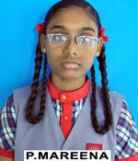
3. | K YAZHINI | 434/500 | 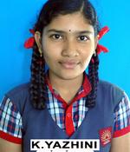

AISSCE (XII)- 2020
SUBJECT WISE P.I.
- Science Stream:-
SUBJECT | TEACHER’S NAME | P.I.
PHYSICS | Mr. Pawan Kumar | 73.21
CHEMISTRY | Mr. Mohan Lal | 72.62
MATHS | Mrs. Kasthuri | 67.76
ENGLISH | Sh. K.C. Khatiresh Kumar | 58.98
HINDI | Mr. Susheel Kumar Garg | 58.33
COMP. SC. | Ms. Tarannum Shaikh | 54.17
BIOLOGY | Smt. S Lakshmi | 49.17

- Commerce Sream:-
SUBJECT | TEACHER’S NAME | P.I.
ACCOUNTANCY | Mrs. Anitha | 70.4
BUSINESS STUDIES | Mrs. Anitha | 65.9
ECONOMICS | Mr. C Vijaya Kr. | 59.1
I.P. | Ms. Tarannum Shaikh | 55.3

