KENDRIYA VIDYALAYA, MANDAPAM
AISSE (X) 2019-20 RESULT
- Pass Percentage- 100%
- School P.I.- 51.62

VIDYALAYA’S TOPPERS

Position | Name | Score | Photo
1. | S VEVIDAA | 459/500 | 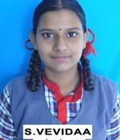
2. | S H FATHIMA SAJA | 427/500 | 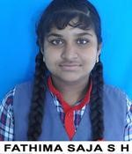
3. | S PRADEEPA GANDHI | 425/500 | 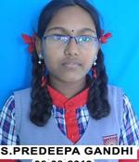
AISSE (X)-2020 RESULT
SUBJECT WISE P.I.
SUBJECT | TEACHER’S NAME | P.I.
HINDI | Mr. Susheel Kumar Garg | 57.03
MATHS(STD.) | Mr. Krishan Kumar Varma  Mrs. Kasthuri | 56.69
SOCIAL STUDIES | Mr. Neeraj Panwar | 54.61
SCIENCE | Mrs. S Lakshmi  Mr. Pawan Kumar  Mr. Mohan Lal | 51.1
MATHS(BASIC) | Mr. Krishan Kumar Varma  Mrs. Kasthuri | 50.0
ENGLISH | Sh. K C Kathiresh Kumar | 48.25
SANSKRIT | Mr. Devesh Kumar | 39

